About Anthony Giannini (Aura of Truth)

Facebook: @AuraofTruth
Instagram: @Auraoftruth

I am here to serve you on your life journey of expansion and healing. BLESSINGS!

I am a Socio-Cultural Anthropologist with a specialized research focus on cross-comparative religious studies, mysticism, altered states of consciousness, and shamanism. I am working to bring indigenous, innovative, and revolutionary holistic healing methods into the mainstream - to serve humanity in truth and to serve the expansion of human consciousness.

I have a weekly podcast, ‘The Aura of Truth Radio Show’ – an anthropological radio show investigating topics on the fringe of mainstream cultural reality.
Stream now on www.soundcloud.com/auraoftruth

Also please visit my online store www.etsy.com/auraoftruth
Through my online store you can purchase orgone energy tools and PRISMA color visionary art prints.
My crafts are infused with the highest intentions and prayers. I enjoy creating PRISMA color pencil drawings of my visions and meditations. My art works are multi-dimensional mandalas that align our energy with our higher self, our truth within oneness, and cosmic states of consciousness.
I create orgone energy healing devices to protect and fortify our bodies against harmful EMF signatures. Orgone energy tools also connect us to higher states of awareness with a relaxed, focused state of being. Orgone energy tools serve many purposes, and will serve each individual's needs according to their intention.
As created by Wilhelm Reich, Orgone energy tools generate 'orgone' energy (prana, life-force, qi, aether, vital energy). Orgone generators work with the aethers to cleanse and protect the vital energy flow of a surrounding area.
Orgone energy tools are great for your home to combat harmful EMF signatures that come from electronic devices. Place orgone energy generators near your computer, tv, WiFi router, etc.
Orgone energy tools are a great way to 'charge' your food and water with life force energy before consumption.
When placed next to your bed as you sleep, orgone energy generators will improve sleep cycles and allow a more restful sleep.
Orgone energy generators can also enhance your dreams, and improve dream recall.
Place orgone energy generators on an altar or sacred space as a way to connect with the divine.
I am deeply grateful for your support. All proceeds continue to fund my work and research as a natural medicine practitioner.

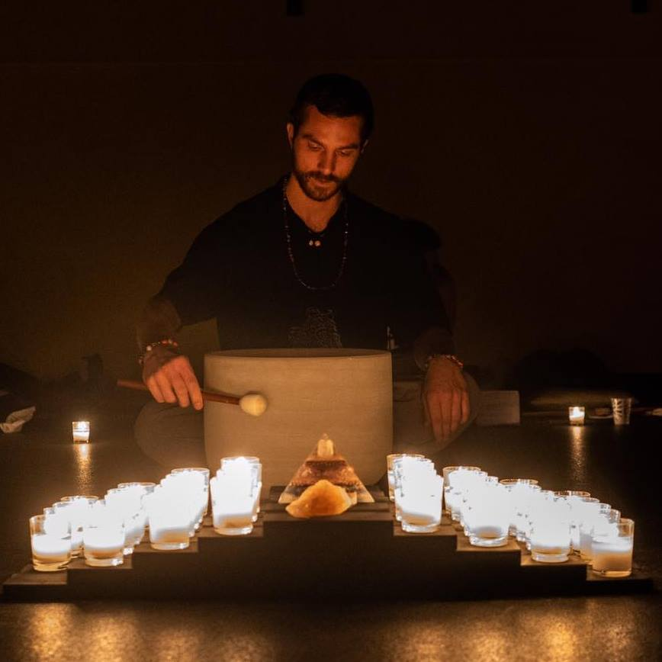 Anthony leading a sound healing meditation
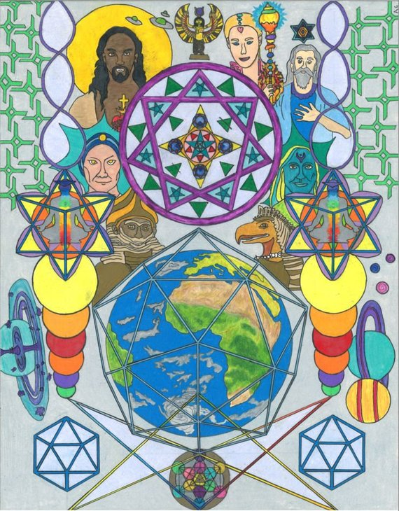
Ascension – PRISMA color art print available on etsy.com/auraoftruth
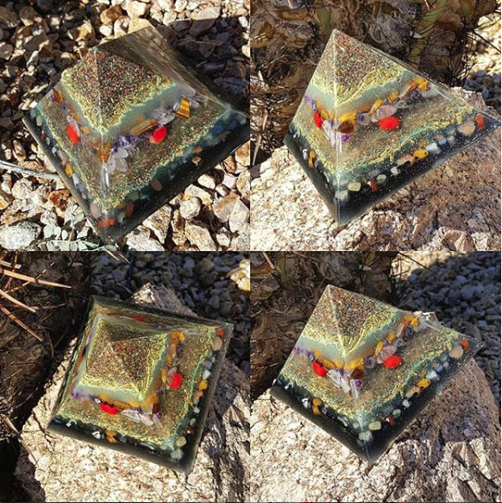Custom Orgone Energy Pyramid

